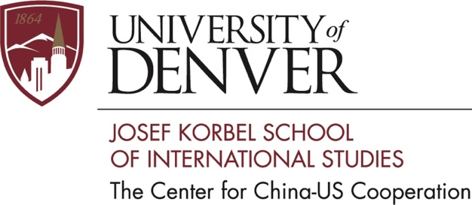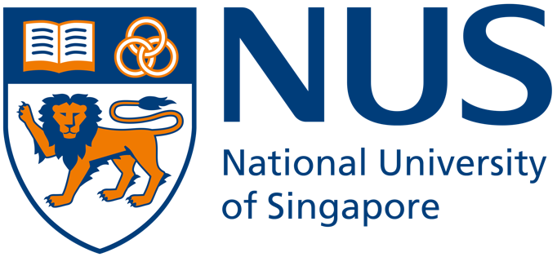

Conference Program

IR Theory and China-India Relations

Joint Sponsored by
The Center for China-US Cooperation, Korbel School of International Studies
University of Denver
&
The Centre on Asia and Globalisation,
Lee Kuan Yew School of Public Policy, National University of Singapore

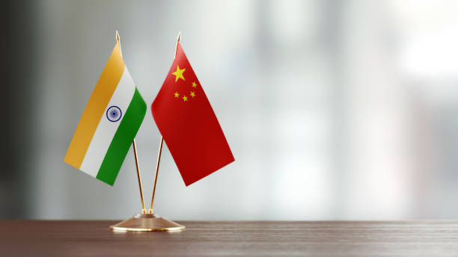
for special issue of Journal of Contemporary China

November 19-21, 2021
Virtual event
Registration required at

https://udenver.zoom.us/meeting/register/tZUof-GspjosG9clSkFM7rNJfBBP2nyWIS46

China and India are both frequently cited as rising states in the international system, which have already gained considerable power and are projected to continue their ascents in the ranks of great powers for the foreseeable future. What does the simultaneous rise of China and India relative to the West, coupled with China’s prospective decline relative to India in the long term, mean for the Sino-Indian bilateral relationship, the Asia-Pacific region, and the global international order? Sino-Indian relations have been subjected to very little inquiry using rigorous theory. This conference is designed to address the theoretical lacunae in the literature on China-India relations by bringing together leading international relations theorists and experts on Chinese and Indian foreign policy. In aggregation, the conference papers aim to advance novel explanations for empirical puzzles in China-India relations, generalize from these explanations to advance new developments in IR theory, and derive prescriptions and predictions for contemporary policy makers.

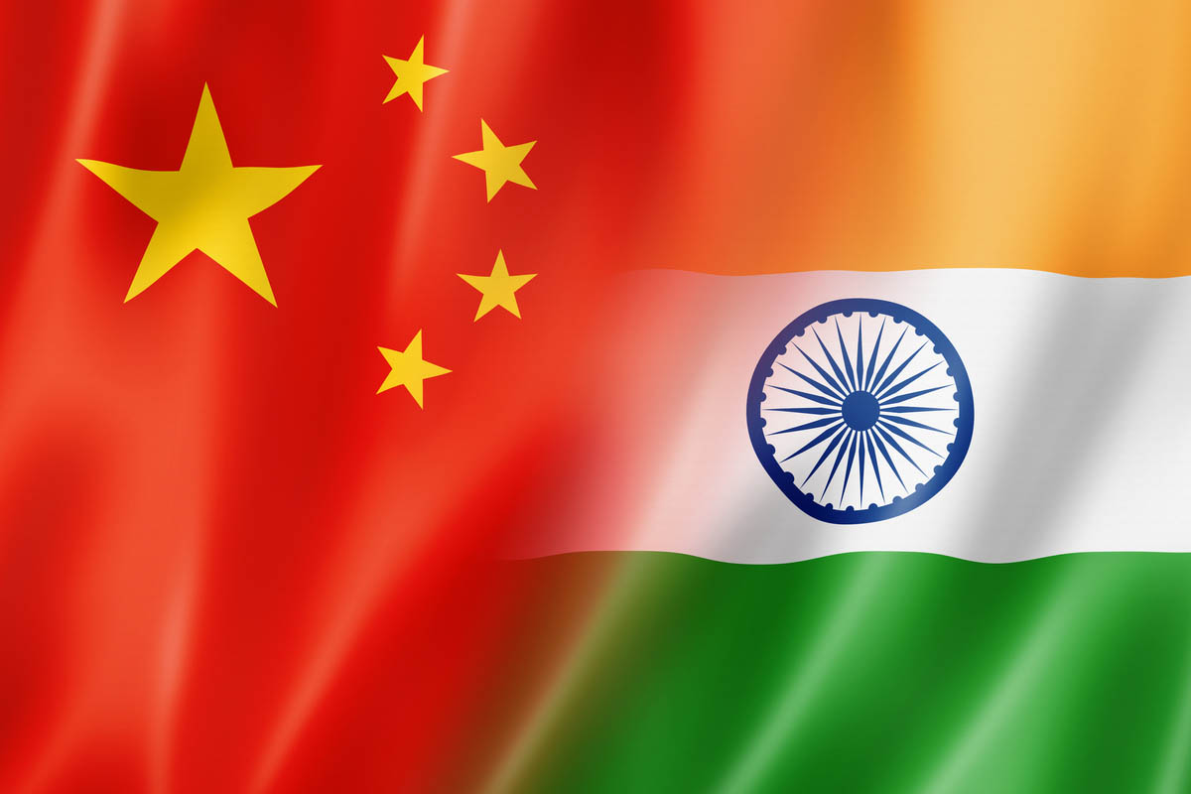
Day 1, November 19/20

1700-1710 November 19, PST, USA
1800-1810 November 19, MST, USA
2000-2010 November 19, EST, USA
0900-0910, November 20, Singapore/Hong Kong Time
Opening Remarks:

Suisheng Zhao, Professor and Director of the Center for China-US Cooperation at Josef Korbel School of International Studies, University of Denver, and Founding Editor, Journal of Contemporary China

Brandon Yoder, Lecturer (Assistant Professor), College of Arts and Social Science, ANU, and Adjunct Research Fellow, Centre on Asia and Globalisation, Lee Kuan Yew School of Public Policy, National University of Singapore

Kanti Bajpai, Wilmar Professor of Asian Studies and Director, Centre on Asia and Globalisation, Lee Kuan Yew School of Public Policy, National University of Singapore

1710-1810 November 19, PST, USA
1810-1910 November 19, MST, USA
2010-2110 November 19, EST, USA
0910–1010 November 20, Singapore/Hong Kong Time

“Balancing, Threats & Wedges in International Political Economy: The Origins and Impact of the Sino-Indian Alliance at the WTO” - Kristen Hopewell, University of British Columbia

Discussant: Gregory Shaffer, Irvine School of Law, University of California
Moderator: Suisheng Zhao

1810-1910 November 19, PST, USA
1910-2010 November 19, MST, USA
2110-2210 November 19, EST, USA
1010 to 1110 November 20, Singapore/Hong Kong Time

“Rising Powers and Normative Resistance: China, India and the Responsibility to Protect” -Courtney J. Fung, University of Hong Kong
Discussant: Alvin Camba, Josef Korbel School of International Studies, University of Denver
Moderator: Suisheng Zhao

Day 2, November 20/21

1700-1800 November 20, PST, USA
1800-1900 November 20, MST, USA
2000-2100 November 20, EST, USA
0900-1000 November 21, Singapore/Hong Kong Time
1130-1230 November 21, Adelaide Time

“China-India Face-offs: How Does Reputation Matter?”
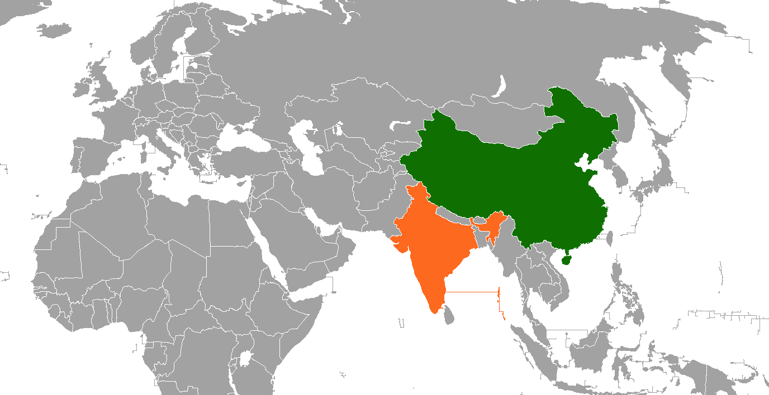
-Deepa Ollapally, George Washington University
Discussant: Priya Chacko, University of Adelaide
Moderator: Suisheng Zhao

1800-1900 November 20, PST, USA
1900-2000 November 20, MST, USA
2100-2200 November 20, EST, USA
1000-1100 November 21, Singapore/HK Time

“Explaining Chinese Military Coercion in Sino-Indian Border Disputes”
-Ketian Zhang, George Mason University
Discussant: Avery Goldstein, University of Pennsylvania
Moderator: Suisheng Zhao

Bios of authors and discussants

AUTHORS
Kanti Bajpai is Wilmar Professor of Asian Studies and Director, Centre on Asia and Globalisation, Lee Kuan Yew School of Public Policy, National University of Singapore. His research focuses on Indian foreign policy and national security, comparative international and strategic thought, and the international relations of South Asia. His recent works include India Versus China: Why They Are Not Friends (2021) and the Routledge Handbook of China-India Relations (2020, co-edited with Selina Ho and Manjari Chatterjee Miller). He is currently directing a project on Asian conceptions of international order.
Courtney J. Fung is an associate professor of International Relations at The University of Hong Kong and concurrently an associate-in-research at the Fairbank Center for Chinese Studies at Harvard University and an associate fellow in the Asia-Pacific Programme at Chatham House/The Royal Institute of International Affairs. She is author of China and Intervention at the UN Security Council: Reconciling Status (Oxford University Press, 2019).
Kristen Hopewell is the Canada Research Chair in Global Policy in the School of Public Policy and Global Affairs at the University of British Columbia and is currently a Wilson China Fellow at the Wilson Center in Washington, DC. Her research specializes in international trade, global governance, and development, with a focus on emerging powers such as China, India and Brazil. She is the author of Clash of Powers: US-China Rivalry in Global Trade Governance (Cambridge University Press, 2020) and Breaking the WTO (Stanford University Press, 2016). Her policy analysis has appeared in venues such as The Washington Post, Foreign Affairs, The South China Morning Post, The Globe and Mail and the BBC.
Deepa Ollapally is Research Professor of International Affairs and the Associate Director of the Sigur Center at George Washington University. She specializes in Indian foreign policy and South Asian and Indo-Pacific security. She also directs the Rising Powers Initiative, a major research program which tracks and analyzes foreign policy debates in aspiring powers of Asia and Eurasia. Dr. Ollapally is the author of five books including Worldviews of Aspiring Powers (Oxford, 2012) and The Politics of Extremism in South Asia (Cambridge 2008), and the editor of Energy Security in Asia and Eurasia (Routledge, 2017) and Nuclear Debates in Asia: The Role of Geopolitics and Domestic Processes (Rowman & Littlefield, 2016).
Brandon Yoder is a Lecturer (Assistant Professor) in the School of Politics and International Relations at the Australian National University, and a non-resident Research Fellow in the Lee Kuan Yew School of Public Policy, National University of Singapore. His scholarship centers on international relations theory and the politics of China and East Asia, and employs a combination of formal models, historical case studies and laboratory experiments. He is the editor of a special issue of International Politics titled “International Relations Theory and China-Russia Relations after the Cold War” (2020). His work has been published or is forthcoming at leading journals in the field, such as the American Journal of Political Science, International Organization, and the Journal of Conflict Resolution.
Ketian Vivian Zhang is an Assistant Professor of International Security in the Schar School of Policy and Government at George Mason University. She studies rising powers, coercion, economic statecraft, and maritime disputes, with a regional focus on China and East Asia. Her book project examines when, why, and how China uses coercion when faced with issues of national security, such as territorial disputes in the South and East China Seas, foreign arms sales to Taiwan, and foreign leaders’ reception of the Dalai Lama. Part of this research has appeared in International Security and the Brookings Institution Press.
DISCUSSANTS
Alvin Camba is an assistant professor at the Josef Korbel School of International Studies at the University of Denver. He is also a faculty affiliate at the Climate Policy Lab at Tufts University and the Sié Chéou-Kang Center for International Security & Diplomacy, as well as a non-resident fellow at the Stratbase-Alberto Del Rosario Institute in the Philippines and the Paramadina Public Policy Institute in Indonesia. Dr. Camba has conducted in-depth research on Chinese capital in Southeast Asia, published numerous peer-reviewed articles in top development journals, and been awarded multiple best research paper awards by sections of the American Sociological Association. His work has contributed to widely-circulated policy reports, and been presented at the World Bank, AidData, and the US State Department.
Priya Chacko is in the Department of Politics and International Relations at the University of Adelaide and Visiting Academic Fellow at the Australia-India Institute. She writes on Indian politics and foreign policy and her current research focusses on the rise of authoritarian populism and economic nationalism in contemporary India.
Avery Goldstein is the David M. Knott Professor of Global Politics and International Relations in the Political Science Department, Inaugural Director of the Center for the Study of Contemporary China, and Associate Director of the Christopher H. Browne Center for International Politics at the University of Pennsylvania. Goldstein is also a Senior Fellow at the Foreign Policy Research Institute in Philadelphia. His research focuses on international relations, security studies, and Chinese politics.

Gregory Shaffer is Chancellor’s Professor of Law and Political Science and Director of the Center on Globalization, Law and Society (GLAS) at the University of California, Irvine School of Law. He is President-Elect of the American Society of International Law, and a member of the Board of Editors of the American Journal of International Law and the Journal of International Economic Law, among others. His publications include over one hundred articles and book chapters and nine books, the most recent of which are Emerging Powers and the World Trade System: The Past and Future of International Economic Law (CUP 2021); The Globalization of Legal Education: A Critical Perspective (with Garth, OUP forthcoming); Transnational Legal Ordering of Criminal Justice (with Aaronson, CUP 2020); and Constitution-Making as a Transnational Legal Order (with Ginsburg and Halliday, CUP 2019).

